1. Create a S3 bucket, with no public access and upload files to the bucket & view the logs using cloudwatch for the uploaded files.

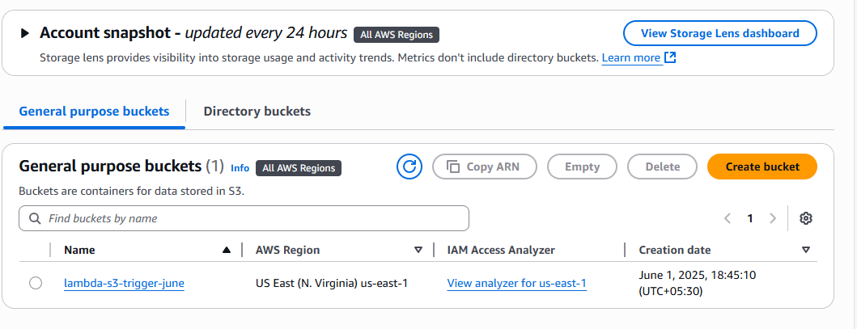

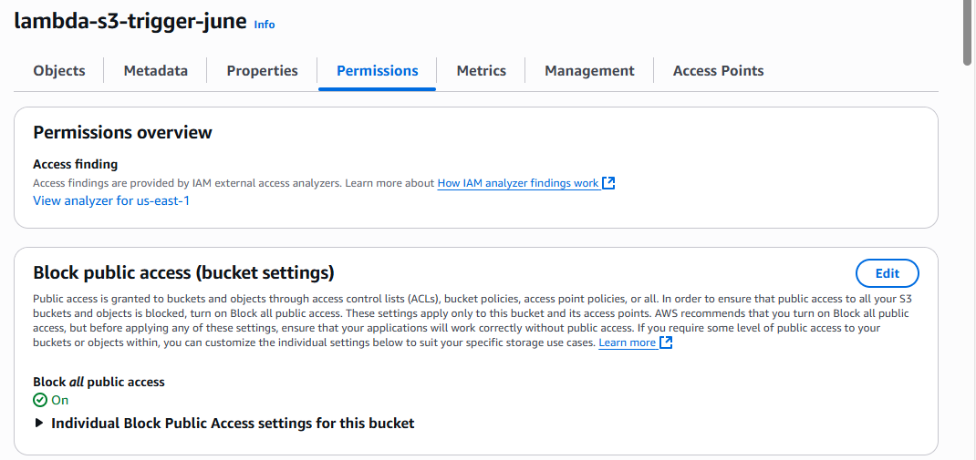

Objects uploaded in s3 bucket

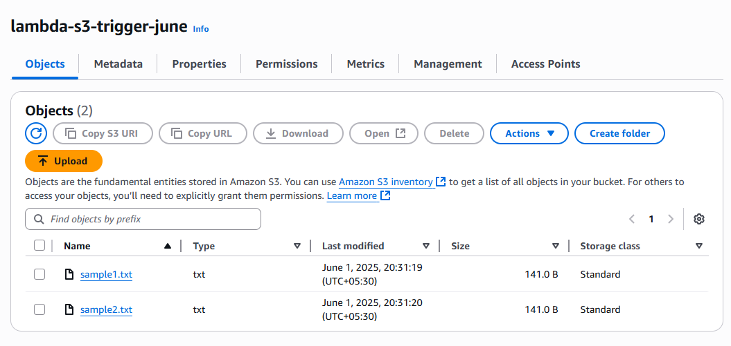

Lambda function

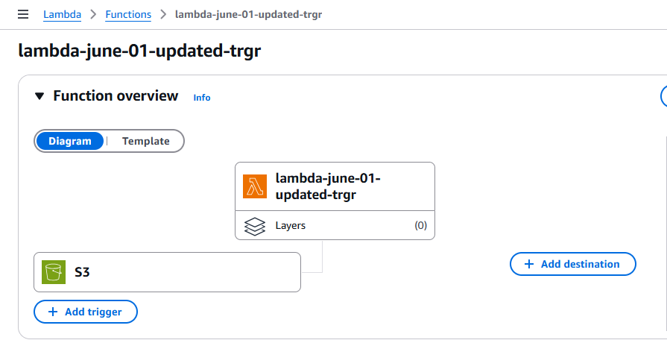

S3_event_trigger

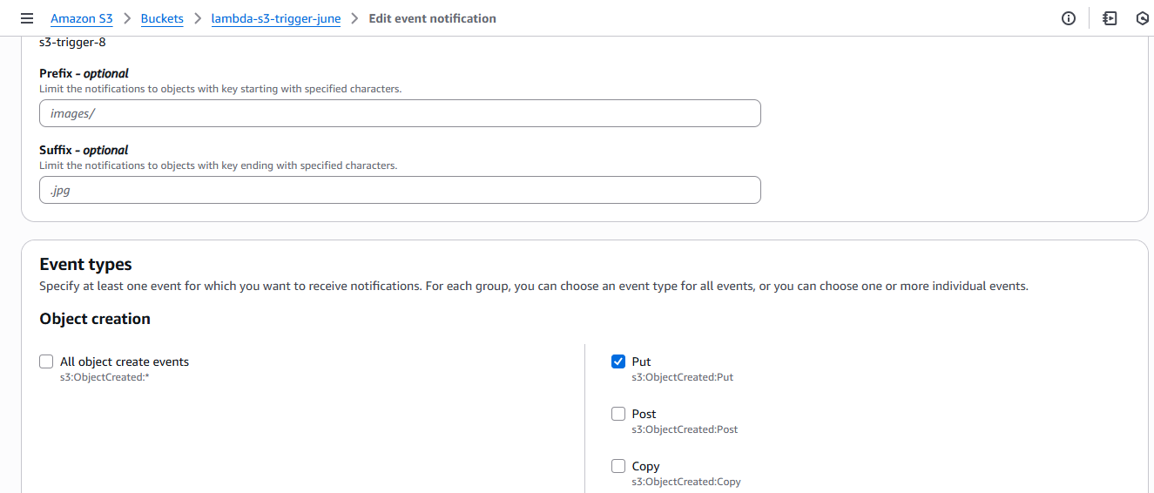

Lambda code to collect the events from s3 trigger

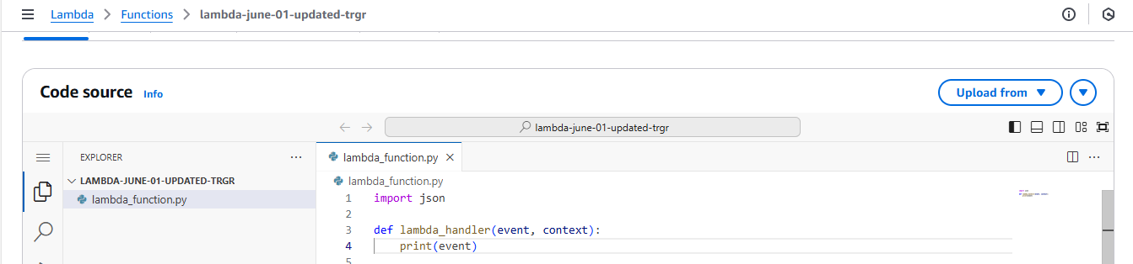

Cloudwatch logs for the objects which uploaded in s3 bucket

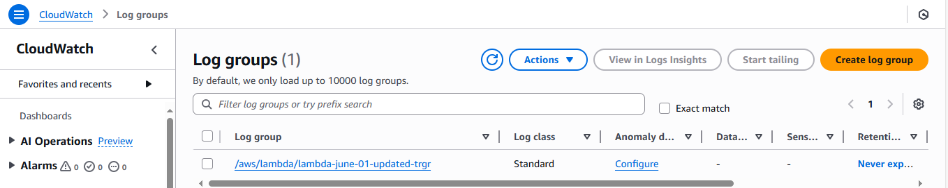  
  
  
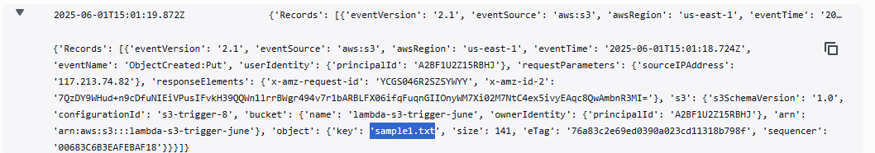

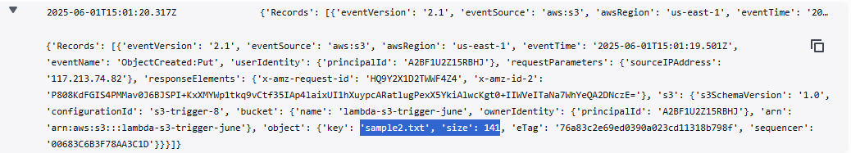

1. Launch two ec2-instances and connect it to a application load balancer, where the output traffic from the server must be an load balancer IP address

2 ec2 servers are launched and apache2 were installed in 2 of them.

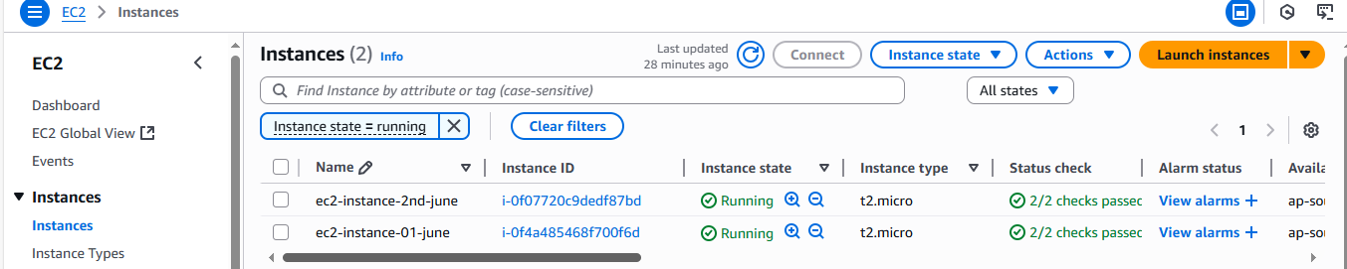



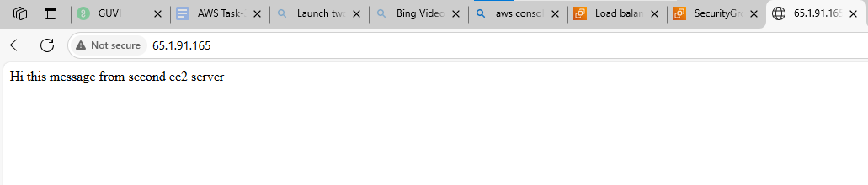

In below screenshot 2 ec2 instances are mapped the target group

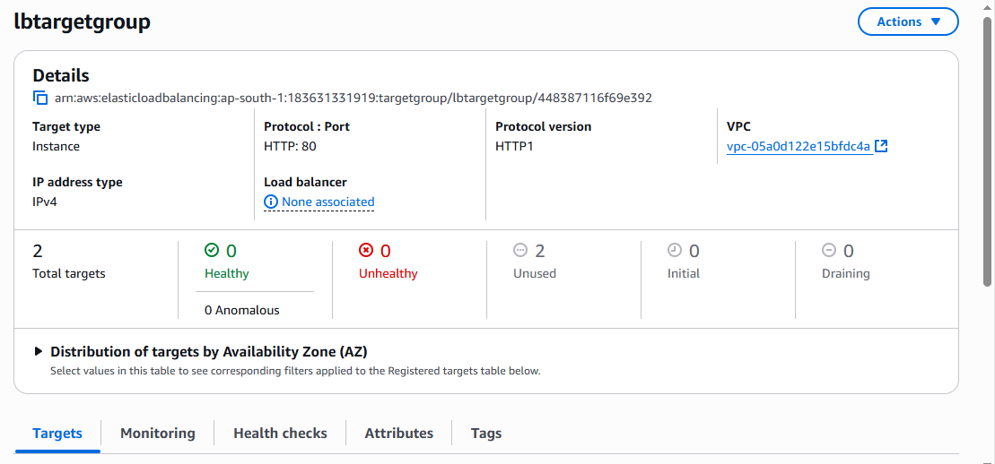

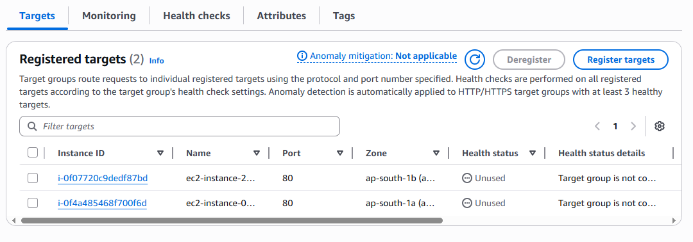

Created the security group for the load balancer.

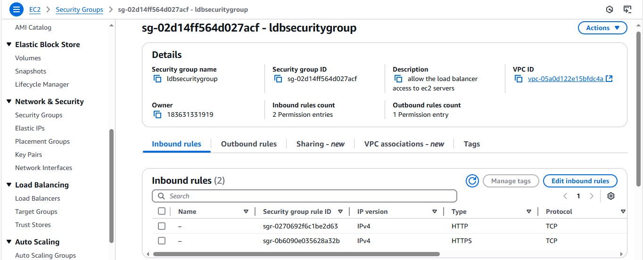

Load balancer is created at this stage. And now we checked the output traffic for those 2 ec2 instances with load balancer DNS name and with same ip address we can access both of the servers.

